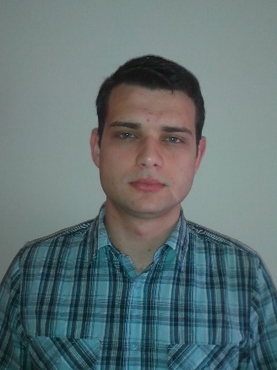
Srđan Maravić
Date of birth: 17/03/1988
Address: 4a Mića Radaković Street,
11080 Zemun, Serbia
Cell phone: +381 66204290
E-mail: srdjanmaravic@gmail.com
LinkedIn: rs.linkedin.com/in/srdjanmaravic/

Work Experience Incident Manager – Internship FEB 2013 – MAR 2013
Telekom Srbija d.o.o.
Web Marketing Manager APR 2014 – JUN 2014
Consalteam Agency
Programmer/DBA/DBD JUN 2014 – SEP 2014
Mega Computer Engineering

Education IT Academy – Programming Department NOV 2013 – PRESENT
Direction: PHP Web Development
Faculty of Technical Sciences - 2007 – 2013
Kragujevac University
Direction: Informatics Engineer
Technical School 2003 – 2007
Direction: Electronics Technician
Trainings Database design and programming with SQL – Oracle Academy
MS SQL Server 2012 Database Fundamentals – Microsoft Virtual Academy
Querying Microsoft SQL Server 2012 Databases – Microsoft Virtual Academy

Computer Skills Advanced knowledge of MS Office (Word, Excel, PowerPoint)
Advanced knowledge of UML
Advanced knowledge of SQL
Advanced knowledge of HTML and CSS
Good command of PHP and JavaScript
Good command of Internet Marketing
Good command of Wordpress
Good command of computer networks
Good command of Apache administration
Good command of Linux/UNIX, Mac OS X
Basic knowledge of AJAX,JSON, AngularJS, Node.JS, GIT,C#

Language Skills English
(communication, writing, reading) – fluent

Profile - Efficient problem solving skills
- Excellent communication and interpersonal skills
- Quick identification of improvement possibilities
- Good time management
- Organized, systematic, analytical, accurate, proactive
- Complete dedication to work

